The Registration Email is not sent after creating an EVOLT Account

Issue
A customer has created an EVOLT account either on the mobile device or the scanner, but the activation/registration email has not been received.
- Have the customer check their spam folder for the email
- Check SendGrid to ensure that the customer is not unsubscribed to our emails
  - If the member is unsubscribed; delete the email from “Global Unsubscribes”


  - Send a Password Reset Link from the webapp forgot password page:
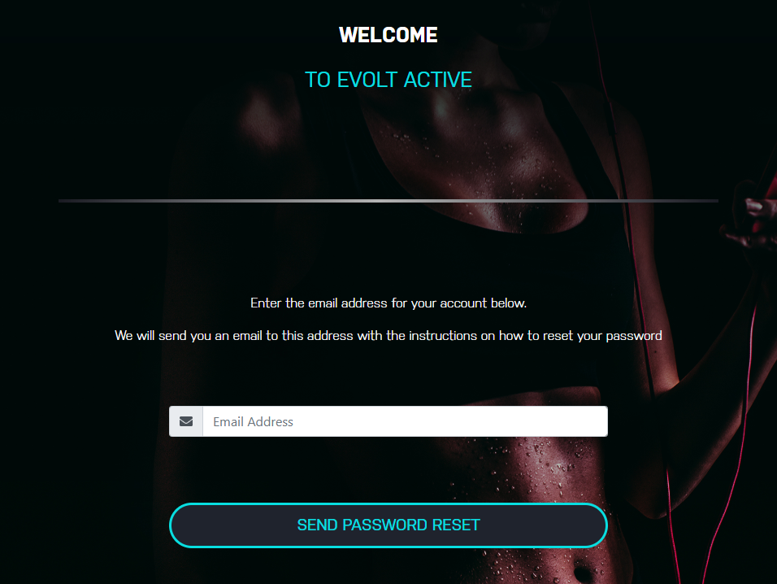
    - EVOLT IOH
  - Check to ensure the customer has received the password reset link and have them set a new password; they should then be able to log in which activates the account.
  - If the issue persists and they created their account on the EVOLT Scanner; ask for the facility they scanned at so we can contact/check that the scanner at the facility is connected to the internet. If it is offline, then the new members profile data will have not been uploaded and the unit must be connected to the internet.

